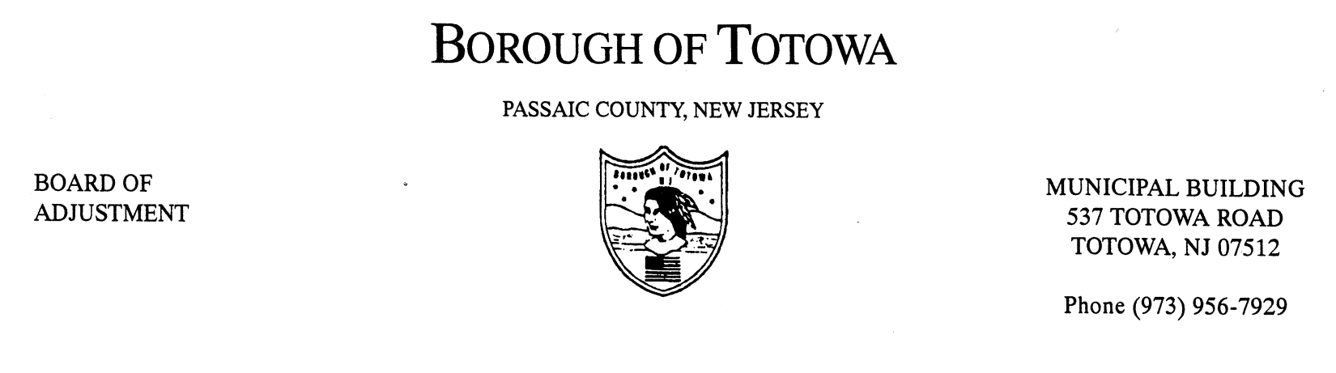
BOROUGH OF TOTOWA
BOARD OF ADJUSTMENT MINUTES
SEPTEMBER 12, 2012

The September 12, 2012 regular meeting of the Borough of Totowa Board of Adjustment was held at the Municipal Building. Chairman Fierro called the meeting to order at 8:00 p.m.; followed by the Flag Salute. Attorney Richard Brigliadoro read the Open Public Meetings Act.

Roll Call:
Present: Chairman Fierro, Vice Chairman Krautheim, Commissioners Niland, Patten, D’Ambrosio, Mancini, Alternate Cortese, Attorney Brigliadoro, Engineer Murphy, Secretary Rattino.
Excused: Attorney Saracino, Commissioner D’Aiuto, Alternate Korsakoff.

A motion to accept the minutes of the July 2012 meeting was made by Commissioner Patten and seconded by Vice Chairman Krautheim. On a roll call vote all Commissioners present voted in the affirmative. The August 2012 meeting was cancelled – no minutes for August.

1ST CASE: FRANKLIN G. SOTO (CARRY-OVER)
101 DEWEY AVENUE, BLOCK 115, LOT 33
Applicant requesting necessary variance(s) for construction of a bedroom within the attic space of a two-family home located in a single family zone – expansion of a non-conforming use. Notice is not proper – there are defects. This case will not be heard for legal reasons. The public was notified and this case will be carried to the October 10, 2012 meeting.

2ND CASE: JHL REALTY D/B/A THE BARNYARD AND CARRIAGE HOUSE (CARRY)
754 TOTOWA ROAD, BLOCK 9, LOTS 44 AND 45
Service in order. Applicant requesting necessary variance(s) for a non-conforming use removal and replacement with new non-conforming use – parking, outside storage and any others that may be required. Attorney Brigliadoro reviewed the complete history for the Barnyard application with the Board.

Michael Holland was sworn. A rental auto body shop left and the rental is proposed to be changed to Carlo Spinella Landscaping. Carlo Spinella was sworn. He explained to the Board that he has six vehicles, a shop area and office with no sales of items on sight. The hours are 7:30 a.m. to 5:00 p.m. The company consists of landscaping, construction and maintenance. There will be part time help in the office. The garage will house his tools. This is not a repair shop except for small equipment. The conditions will be the terms of the Consent Judgment – four trucks parked in front of property or where designated. This will operate Monday through Saturday (if there is rain or holidays). There was no public to be heard. The variances were reviewed by the attorney. The exhibits identify all information required. There will be no additional signage or lighting. Engineer Murphy reviewed the variances as well.

A motion to grant the necessary variance(s) was made by Vice Chairman Krautheim and seconded by Commissioner D’Ambrosio. Vote to grant: 7-0. (Tape #1, #1 - #1321).

3RD CASE: ALMAFI CORP.
19 DUFFUS AVENUE, BLOCK 130, LOT 4
Service in order. Applicant requesting necessary variance(s) for accessory structure located within - required side yard setback and any others that may be required. Represented by David Amadio, Esq. This was approved in 1997 (Pombo) for a garage to be built. Now already existing; variance was never sought out. The applicant would like to bring the property into lawful order.

Marisa Bruno is the applicant/owner. Fourteen photos were marked A1 taken by Ms. Bruno two weeks ago. The location was described to the Board. The garage is presently an accessory rental property. There was no public to be heard.

A motion to grant the necessary variance(s) was made by Commissioner Patten and seconded by Commissioner Mancini. Vote to grant: 7-0. (Tape #1, #1370 - #2445).

4TH CASE: ABIL REALTY
195 ROUTE 46 WEST, BLOCK 174, LOT 12
Service in order. Applicant requesting necessary variance(s) for building height – alteration to façade of building. Represented by Carmine Campanile, Esq. They propose to renovate the facade in the plaza. The plans were distributed. The 44 foot height is being exceeded (D Variance). This is proposed to make a better visual. The owner/representative from Abil Realty, William Spina, explained that he lost the side entrance to the site thereby losing a lot of business. The signage is staying the same. The architect plans packet was marked A1.

Michael Spagnolo, Architect, was sworn. Each page of the plans was reviewed with the Board. The existing conditions remain. The roof is not being raised, only façade. The awnings will be close to the curb line and hidden from traffic. The proposed color scheme was reviewed.

Frederick Meola, Planner, was sworn. The engineer drawings packet was marked A2 (five pages). Mr. Meola described the packet to the Board. The site will become more noticeable to the driving public. There was no public to be heard.

A motion to grant the necessary variance(s) was made by Vice Chairman Krautheim and seconded by Commissioner D’Ambrosio. Vote to grant: 7-0. (Tape #1, #2446 - #6442).

THE FOLLOWING RESOLUTION(S) WAS MEMORIALIZED:

1ST CASE: DIMO AND MARIJA GOLCEV
7 ROSELAND AVENUE, BLOCK 154, LOT 25
Variance(s) granted for an addition to home – required variances front yard setback, side yard setback, rear yard setback, F.A.R. and any others that may be required.

2ND CASE: BARNYARD AND CARRIAGE HOUSE
754 TOTOWA ROAD, BLOCK 9, LOT 44
Variance(s) granted for an amended site plan approval – expansion of restaurant and catering hall located in R-40 residential zone, outdoor dining and recreational sports areas within property; site plan approval and parking alterations and any others that may be required.

A motion to adjourn the meeting was made by Commissioner Patten and seconded by Commissioner Mancini. The meeting ended at 9:35 p.m.

Respectfully submitted,
Karen Rattino, Secretary

