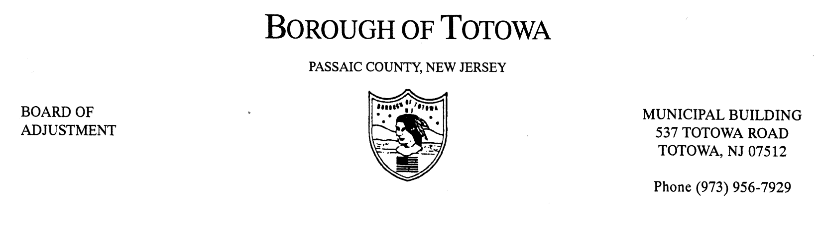
BOARD OF ADJUSTMENT
MINUTES OF JANUARY 9, 2013

The January 12, 2013 regular and reorganization meeting of the Borough of Totowa Board of Adjustment was held at the Municipal Building. Vice Chairman Krautheim called the meeting to order at 8:00 p.m.; followed by the Flag Salute. Attorney William Saracino read the Open Public Meetings Act.

Roll Call:
Present: Chairman Fierro, Vice Chairman Krautheim, Commissioner Niland, Patten, D’Ambrosio, Commissioner Mancini, Commissioner Cuccinello Alternate Korsakoff, Alternate Masi, Attorney Saracino, Engineer Murphy, Secretary Steinhilber.

Commissioner D’Aiuto and Alternate Cortese will be replaced on the Board for 2013. Thanks were extended to both Commissioners.

The 2013 Oaths of Office were received from Municipal Clerk Wassel for Vice Chairman Krauthiem for a 4-year term, Commissioner Cuccinello for a 4-year term, and Alternate Masi for a 2-year term. All Commissioners were sworn.

Nomination for Board Chairman was requested. A motion to appoint Fierro as Chairman was made by Vice Chairman Krauthiem and seconded by Commissioner D’Ambrosio. There being no other nominations from the floor, the nomination for Chairman was closed. On a roll call vote all members present voted in the affirmative and congratulations were extended to Chairman Fierro.

Nomination for Board Vice Chairman was requested. A motion to appoint John Krautheim as Vice Chairman was made by Commissioner Mancini and seconded by Commissioner Patten. There being no other nominations from the floor, the nomination for Vice Chairman was closed. On a roll call vote all members present voted in the affirmative and congratulations were extended to Vice Chairman Krautheim.

Nomination for Board Attorney was requested. A motion to appoint William Saracino as Board Attorney was made by Commissioner Patten and seconded by Commissioner Mancini. There being no other nominations from the floor, the nomination for Board Attorney was closed. On a roll call vote all members present voted in the affirmative and congratulations were extended to Board Attorney Saracino.

Nomination for Secretary was requested. A motion to appoint Pam Steinhilber as Secretary was made by Commissioner D’Ambrosio and seconded by Vice Chairman Krauthiem. There being no other nominations from the floor, the nomination for Secretary was closed. On a roll call vote all members present voted in the affirmative and congratulations were extended to Secretary Steinhilber.
Nomination for Board Engineer was requested. A motion to appoint Nordan Murphy as Board Engineer was made by Commissioner D’Ambrosio and seconded by Commissioner Niland. There being no other nominations from the floor, the nomination for Board Engineer was closed. On a roll call vote all members present voted in the affirmative and congratulations were extended to Board Engineer Murphy.

A motion was made by Vice Chairman Krauthiem and seconded by Commissioner Mancini that the Board of Adjustment will meet the second Wednesday of every month at 8:00 p.m. in the Council Chambers for the year 2013 through January 2014. On a roll call vote, all members present voted in the affirmative.

The reorganization meeting was over and the regular meeting of the Board of Adjustment was called to order by Chairman Fierro.

A motion to accept the minutes of the November 2012 meeting was made by Commissioner D’Ambrosio and seconded by Commissioner Patten. On a roll call vote all Commissioners present voted in the affirmative.

1ST CASE: EMERGENCE CHURCH, INC.
930 N. RIVERVIEW DRIVE, BLOCK 169, LOT 6
Applicant requesting necessary variance(s) for expansion of non-conforming use – church and assembly in I-3 industrial zone. Service in order.

Adjournment for tonight-letter was sent to attorney.

Attorney Saracino relisted for February 13, 2013 @ 8:00p.m. There will be no need to re-notice. The public was notified.

Public to be Heard –NONE

THE FOLLOWING RESOLUTION(S) WAS MEMORIALIZED:

1ST CASE: ADELINA SANTOS BOITEL
101 DEWEY AVENUE, BLOCK 115, LOT 33
Variance(s) denied for construction of a bedroom within the attic space of a two-family hoe located in a single family zone – expansion of a non-conforming use.

A motion to deny the necessary variance(s) was made by Vice Chairman Krauthiem and seconded by Commissioner D’Ambrosio. Vote to deny: 6-1. (Tape #1, #1 - #2679). Vote to approve: Commissioner Mancini.

A motion to adjourn the meeting was made by Commissioner Patten and seconded by Commissioner D’Ambrosio. The meeting was adjourned at 8:40 p.m.

Respectfully submitted,
Pam Steinhilber, Secretary

